# SCREENSHOTS AND TESTCASES

## Displaying the Login page

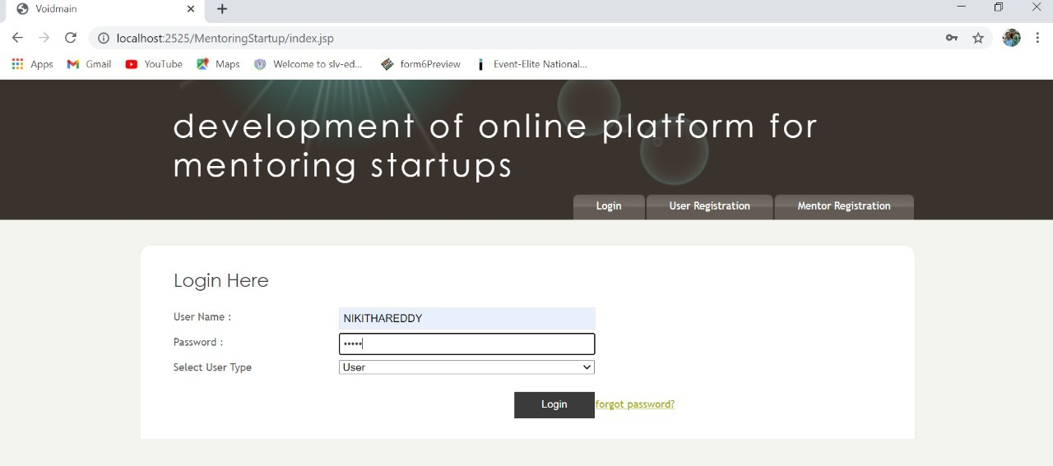

Screenshot 5.1: login page

## Registration page for Mentor and user

## 

Screenshot 5.2: Registration page

**Mentor registration page:**

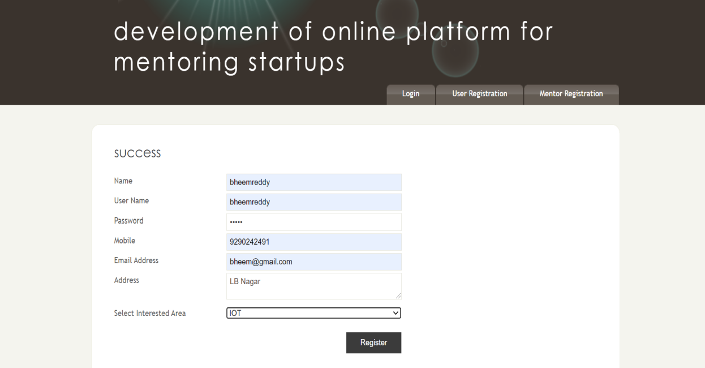

Screenshot 5.3: Mentor Registration page

**Admin-View Mentor page:**

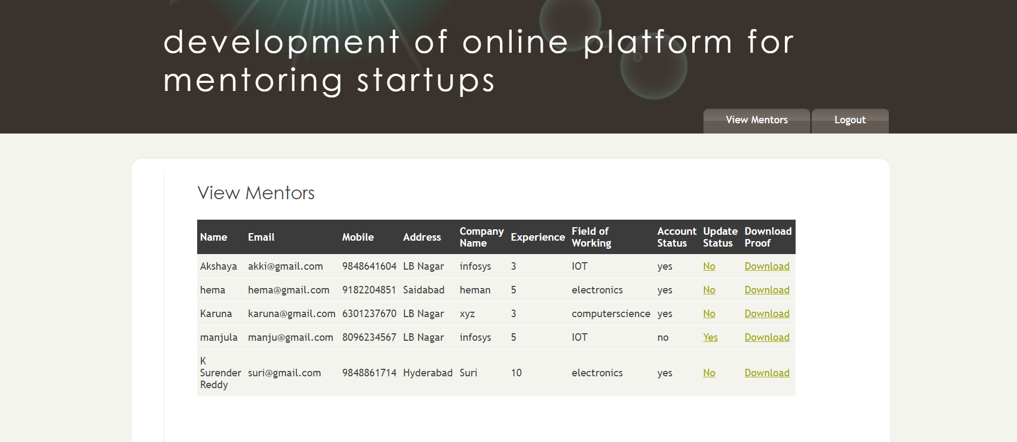

Screenshot 5.4: Admin-view Mentor page

|  |  |  |  |  |
| --- | --- | --- | --- | --- |
| **Test case** | **Input** | **Expected output** | **Actual output** | **Result** |
| Admin page | Admin can view all the mentors | Mentor should be accepted | Accepts mentor | Success |
| Admin page | Admin can view all the mentors | Mentor should be accepted | Rejects mentor | Failed |

**User-View Mentor page:**

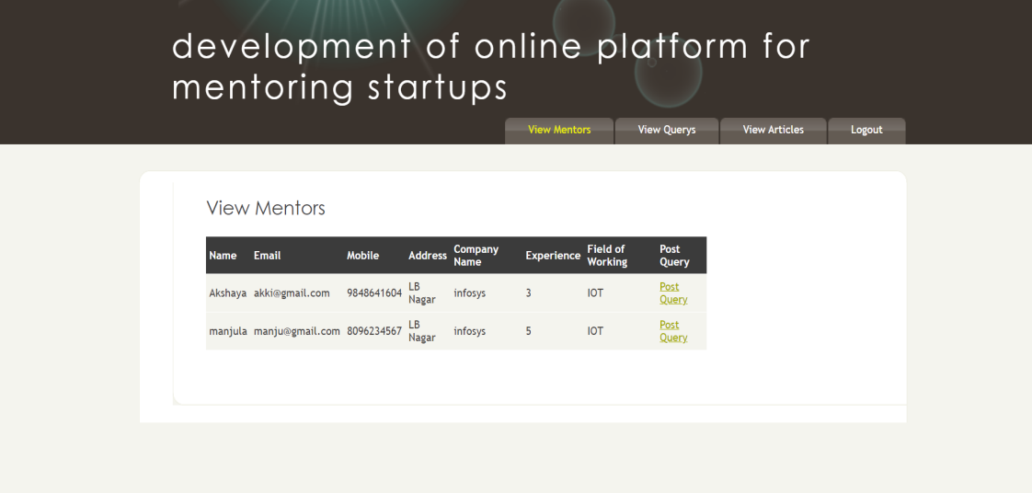

Screenshot 5.5: User-view Mentor page

|  |  |  |  |  |
| --- | --- | --- | --- | --- |
| Test case | Input | Expected output | Actual output | Result |
| User page | user can view all the mentors | User post query’s | Mentor details are viewed and post query’s | Success |
| User page | user can view all the mentors | User post query’s | Mentor details are not viewed | Failed |

**Mentor View query Page:**

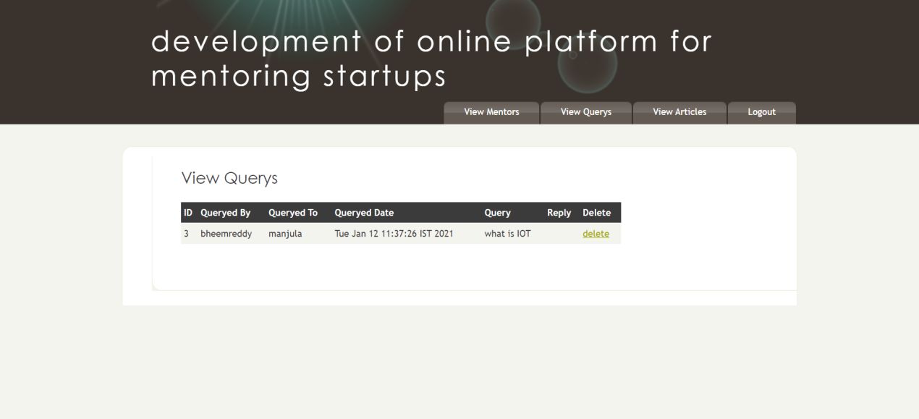

Screenshot 5.6: Mentor view query page

|  |  |  |  |  |
| --- | --- | --- | --- | --- |
| **Test case** | **Description** | **Expected output** | **Actual output** | **Result** |
| View query | user can view query’s posted by him | Delete or view query’s | User can view and delete his querys | Success |
| View query | user can view query’s posted by him | Delete or view query’s | No query’s visible | Failed |

**User View Article Page**

Screenshot 5.7: User view article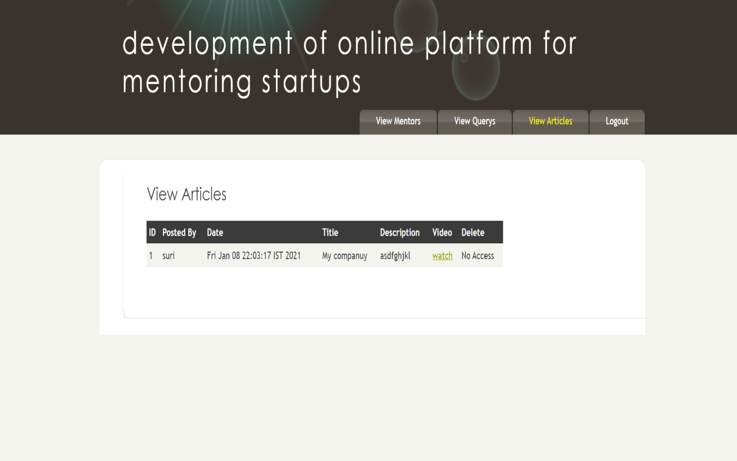 page

|  |  |  |  |  |
| --- | --- | --- | --- | --- |
| **Test case** | **input** | **Expected output** | **Actual output** | **Result** |
| View article | user can view articles | View articles | View articles , watch if any videos posted | Success |
| View article | user can view articles | View articles | No articles visible | Failed |

**Mentor View Query Page**

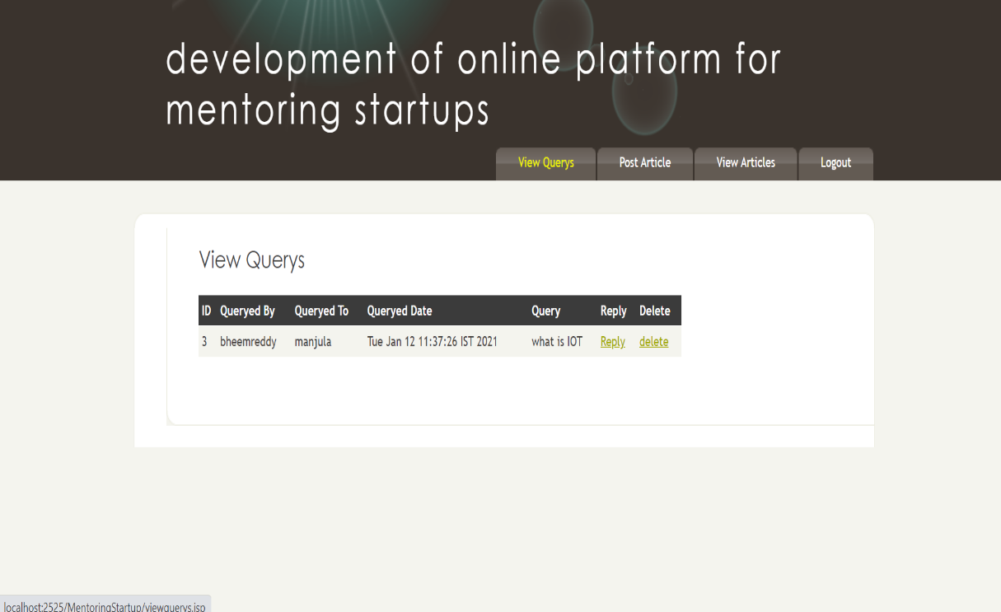

Screenshot 5.8: Mentor View Query Page

|  |  |  |  |  |
| --- | --- | --- | --- | --- |
| **Test case** | **Input** | **Expected output** | **Actual output** | **Result** |
| View query | mentor can see query’s | Reply and delete query | Can reply and delete query | Success |
| View query | mentor can see query’s | Reply and delete query | No query is visible | Failed |

**Mentor Post Article page**

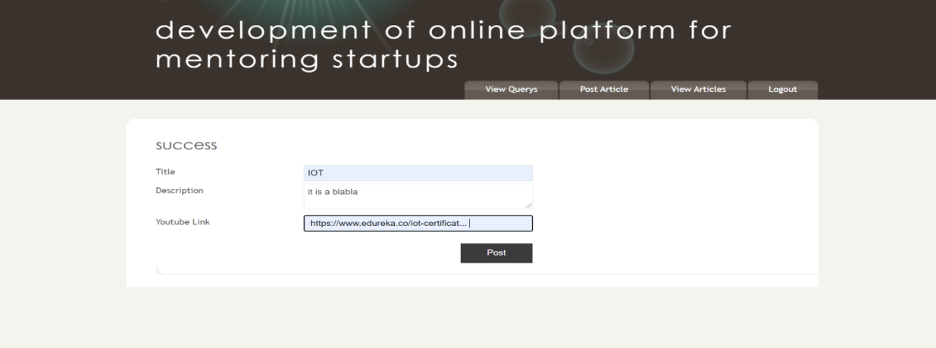

Screenshot 5.9: Mentor Post Article page

|  |  |  |  |  |
| --- | --- | --- | --- | --- |
| **Test case** | **Input** | **Expected output** | **Actual output** | **Result** |
| Mentor page | mentor can post article | Article gets posted | Article gets posted ,success message displays | Success |
| Mentor page | mentor can post article | Article gets posted | Article does not get posted | Failed |

**Mentor View Articles Page**

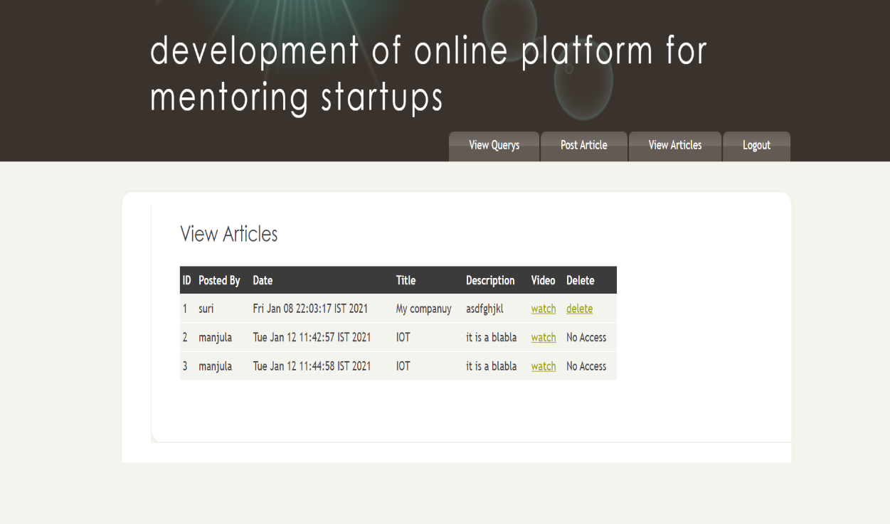

Screenshot 5.10: Mentor View Articles Page

|  |  |  |  |  |
| --- | --- | --- | --- | --- |
| **Test case** | **input** | **Expected output** | **Actual output** | **Result** |
| View article | mentor can post article | Article gets posted and success displays | Article gets posted ,success message | Success |
| View article | mentor can post article | Article gets posted and success displays | Article deleted | Failed |